computational Assigment #5

Brandon Moretz

### Computation

**1.)** *For the 2x2 table, determine the odds and the probabilities of texting while driving among males and females. Then compute the odds ratio of texting while driving that compares males to females.* (**5 points**)

|  |  |  |
| --- | --- | --- |
| **Texting While Driving** | **MALE** | **FEMALE** |
| **YES** | 30 | 34 |
| **NO** | 10 | 6 |

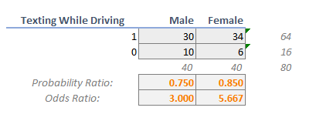

**2.)** *Download the data file RELIGION.CSV and import it into R. Use R and your EDA skills to gain a basic understanding of this dataset. Please note, there is a variable labeled RELSCHOL. This variable indicates if a survey respondent attends a religiously affiliated private secondary school (1) or not (0). Use this dataset to address the following questions:* (**10 points**)

a. *Compute the overall odds and probability of attending a religious school, assuming this data is from a random sample.*

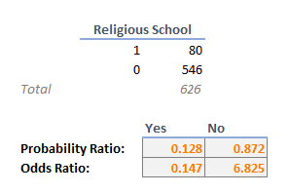

b. *Cross-tabulate RELSCHOL with RACE (coded: 0=non-white, 1=white). What are the probabilities that non-white students and white students attend religious schools? What are the odds that white students and non-white students attend religious schools? What is the odds ratio that compares white and non-white students?*

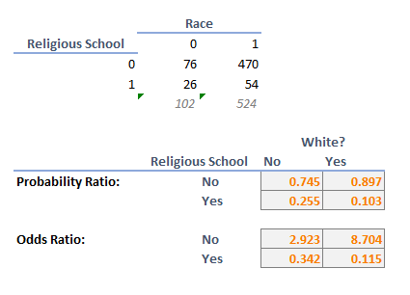

c. Plot *RELSCHOL* (Y) by *INCOME* as a scatterplot.

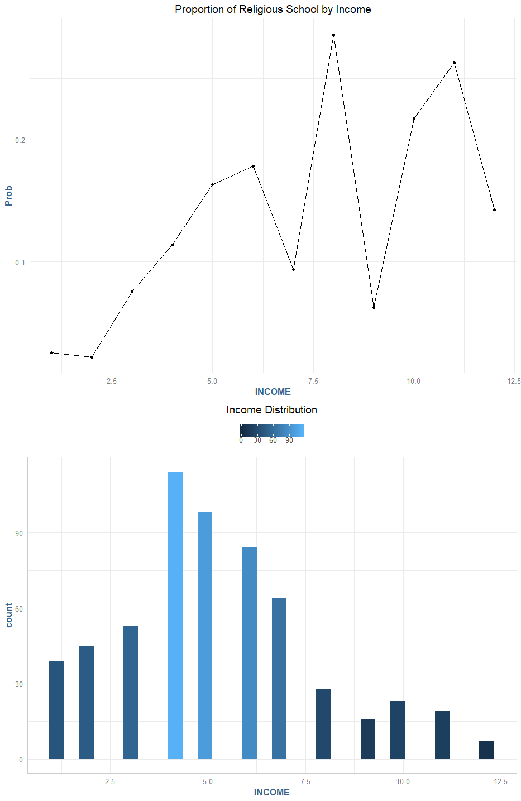

*The INCOME variable is an ordinal variable that is associated with income brackets. This is an old dataset, so for example, INCOME=4 🡪 $20,000-$29,999. Is there a value of INCOME that seems to separate or discriminate between those attending religious schools and those that don’t?*

Those students in the income bracket 8 and over have an average change of 19.43% for attending a religious school, compared to a 9.61% for those students with less than an income of the 8th bracket.

*Create a variable that dichotomizes INCOME based on this value you observed. Call this new variable D_INCOME. Cross-tabulate RELSCHOL with D_INCOME. What are the probabilities that low-income students and higher students attend religious schools? What are the odds that lower income students and higher income students attend religious schools? What is the odds ratio that compares lower and higher income students?*

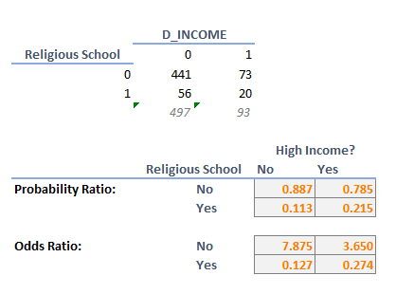

d. *Plot RELSCHOL (Y) by ATTEND as a scatterplot.*

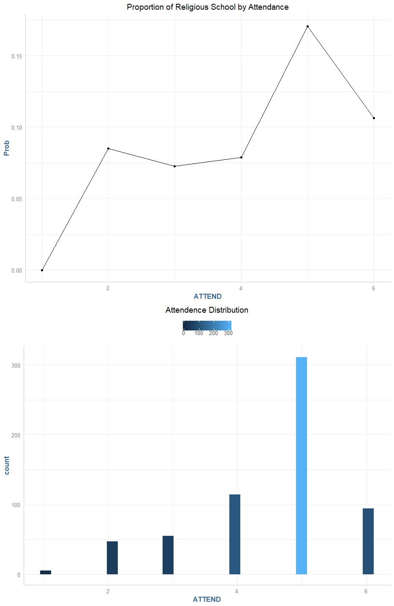

*The ATTEND variable is the number of times the survey respondent attends a service during a month. Cross-tabulate RELSCHOL with ATTEND. Are the proportion profiles the same for those attending religious school versus not, across the values of the ATTEND variable? Is there a value of ATTEND that seems to separate or discriminate between those attending religious schools and those that don’t? Save this value for later.*

The proportion profile for attendance varies across the number of days attended, however, we see the largest spike on day 5.

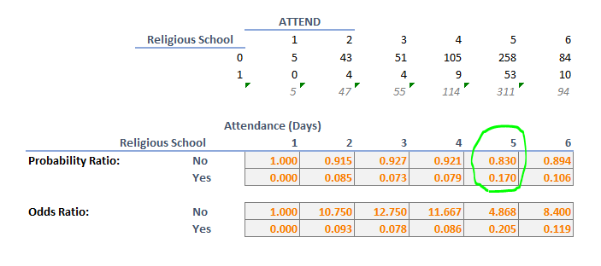

**3.)** *First, fit a logistic model to predict RELSCHOL (Y) using only the RACE (X) variable. Call this Model 1. Report the logistic regression model and interpret the parameter estimates for Model 1. Report the AIC and BIC values for Model.*

(**3 points**)

Model 1

Ŷ = -1.073 – 1.091β1

Where β1 is a binary variable that represents a white vs non-white student (white = 1), and Ŷ is the log odds of a person attending a religious school. The intercept here can be interpreted as:

*exp*(-1.073)/(1 + exp(-1.073)) = **.255**

which denotes roughly a **25.5**% chance that a non-white student (**race = 0**) attends a religious school. The beta coefficient here is interpreted as for a given student, if they are white (**race = 1**), then the probably of that student attending a religious school further decreases by

exp(-1.09)/(1 + exp(-1.09)) = **.251**

an additional **25.1**%. The model information loss statistics are summarized in the table below.

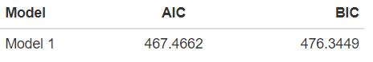

**4.)** *Next, fit a logistic model to predict RELSCHOL (Y) using only the INCOME(X) variable. Call this Model 2. For Model 2, do the following:* (**6 points**)

*a.) Report the logistic regression model and interpret the parameter estimates for Model 2. Report the AIC and BIC values for Model 2. How do these compare to Model 1?*

Model 2

Ŷ = -2.821 + 0.162β1

Where β2 is a binary variable that represents the income bracket for the family the student comes from, and Ŷ is the log odds of a person attending a religious school. The intercept here can be interpreted as:

exp(-2.821)/(1 + exp(-2.821)) = **0.056**

which denotes a roughly **5.6%** chance of a given student attending a religious school ignoring the income bracket of the family. The beta coefficient in this model denotes a

exp(0.162)/(1 + exp(0.162)) = .**54**

or an approximately **54%** increased chance of a student attending religious school per increase in income bracket. If we were to predict the probabilities of a student attending religious school by income bracket, we would predict a steady increase in religious school enrollment through each income bracket. The predicted levels can be seen in the following chart:

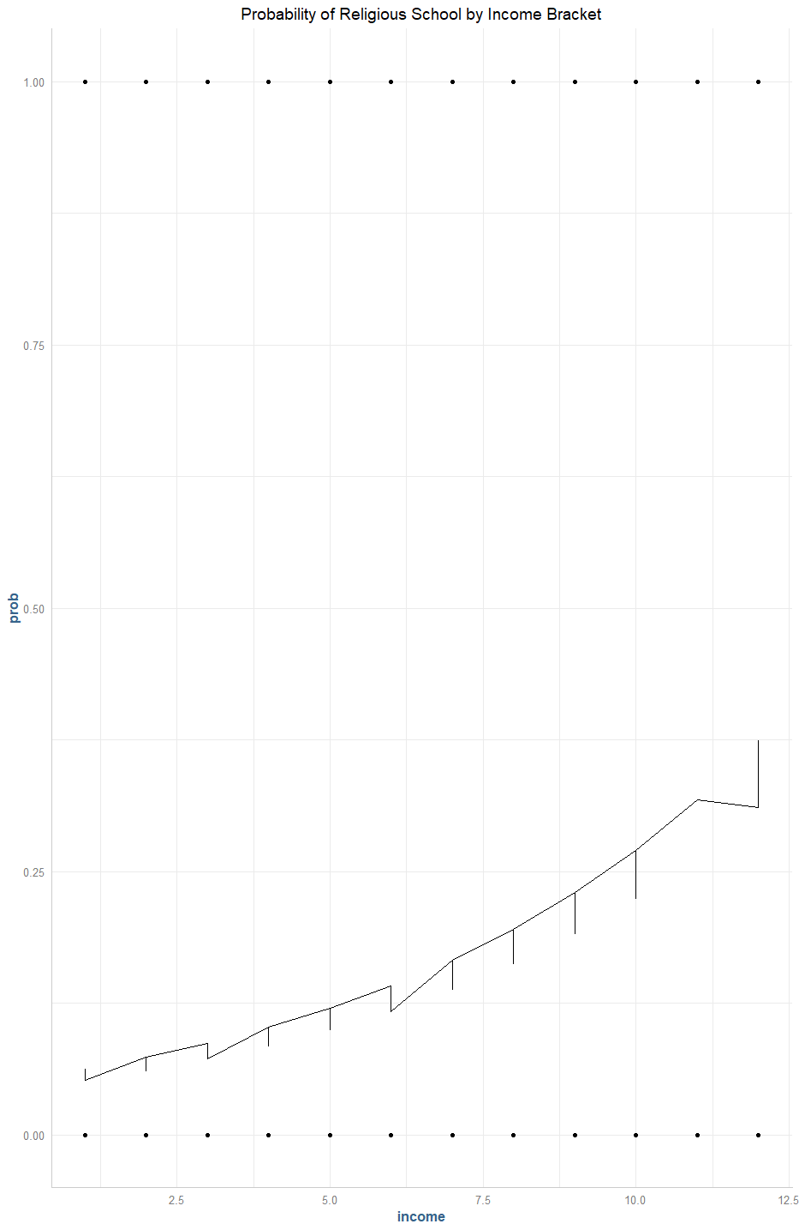

The model fit statistics can be found summarized in the following table:

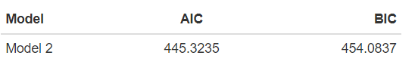

This model is different than the first model in that we see progressively different values for predicted religious school enrollment for various levels of income brackets, where the first model was by a dichotomous variable, race.

*b.) Use the logit predictive equation for Model 2 to compute PI for each record. Plot PI (Y) by INCOME(X). At what value of X, does the value of PI exceed 0.50? How does this value compare to your visual estimate from problem 2c)?*

**5.)** *Next, fit a logistic model to predict RELSCHOL (Y) using only the ATTEND(X) variable. Call this Model 3. For Model 3, do the following:* (**6 points**)

a. *Report the logistic regression model and interpret the parameter estimates for Model 3. Report the AIC and BIC values for Model 3. How do these compare to Models 1 and 2?*

b) *Use the logit predictive equation for Model 3 to compute PI for each record. Plot PI (Y) by INCOME(X). At what value of X, does the value of PI exceed 0.50? How does this value compare to your visual estimate from problem 2d)?*

**6.)** *Finally, fit a logistic model to predict RELSCHOL (Y) using RACE, INCOME and ATTEND as explanatory (X) variables. Please consider INCOME and ATTEND to be continuous variables. Call this Model 4. For Model 4, do the following:* (**9 points**)

a. *Report the logistic regression model and interpret the parameter estimates for Model 4. Report the AIC and BIC values for Model 4. How does this model compare to Modesl 1, 2 and 3?*

b. *For those who attend religious service 5 days per month (attend=5) and have a family income of $20-$29,000 (INCOME=4), what are the predicted odds of attending a religious school for white and non-white students?*

c. *What is the adjusted odds ratio for race? Interpret this odds ratio.*

### Research

**7.)** *For Models 1, 2 and 3, use the logit models to make predictions for RELSCHOL. Note, you will have to calculate the estimated logit and then convert it into PI_estimates for each module. The classification rule is: If PI < 0.50, predict 0; otherwise predict 1 for RELSCHOL. Obtain a cross-tabulation of RELSCHOL with the predicted values for each model. Compare the correct classification rates for each of the three models.* (**6 points**)

### Conclusion

**8.)** *In plain English, what do you conclude about the relationship between a student’s race/ethnicity, religious service attendance, family income and attending a religious school?* (**5 points**)